3th- 5th of May 2019
Individual & Group Exercises
Lebanon
Zouk Mickael

INVITATION
Dear friends,

We have a great pleasure to invite you to participate in
“The Phoenix First International Cup
of Rhythmic Gymnastics”
which will take place on May 3rd till May 5th 2019 at Stade Nouhad Naufal sport Arena, Lebanon - Zouk Mickael.

Preliminary Schedule:
Friday, 3rd of May: Arrival of Delegations, Technical Meeting
Competition Day- depending on number of participants
Saturday, 4th of May: Competition Day
Sunday, 5th of May: Competition Day, Gala-show, Banquet (25$ per person)
Monday, 6th of May: Departure of Delegations
Individual exercises A, B & B light level Delegation: Unlimited number of competitors 1 judge, coaches
Group exercises:
Delegation: Unlimited number of groups 1 judge, coaches
DEADLINES:
Preliminary entry: March 15th, 2019
Definitive entry: April 10th, 2019
Hotel Reservations: April 1st, 2019
Music: April 10th, 2019
Organized by:
Stade Nouhad Naufal

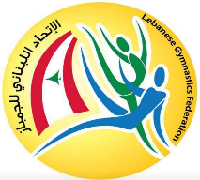
With support of Lebanese Gymnastics Federation

Contact person:
Antoun Khalil
General Manager of Stade Nouhad Naufal: +961 3 348 281
Email: tony@primetime-lb.com
Olga Strizhakova- Bassil
Coordinator/Coach of Rhythmic Gymnastics: + 961 79129181 (what’s app)
Email: ostrizh@hotmail.com
COST:
Program individual – 45 $ USA per gymnasts.
Program group –25 $ USA per gymnast.
Registration
All applications must be send to e-mail: ostrizh@hotmail.com not later than
April 10th, 2019.
Awards
Diplomas and presents for all gymnasts.
Each category from 1st to 3rd place gets medals.
Winner of the Competition is awarded with the Tournament Cup.
Music
Music for the competition must be record in mp3 format on own CD-R disc or USB also with each music routine.
All the music should be sent on email: ostrizh@hotmail.com in mp3 format not later than 10th of April 2019 with the name of gymnasts and routine.
Judges
Each delegation must include 1 judge, 1 coach, unlimited numbers of participants.
Each delegation must ensure the work of judge throughout the three days of competitions.
On the days when the judge is working lunches are provided at the organizer’s cost.
Accomodation
Princessa Hotel, Lebanon****
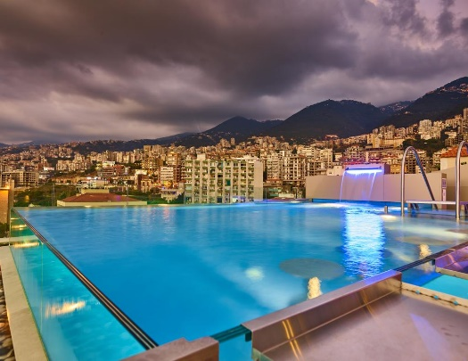
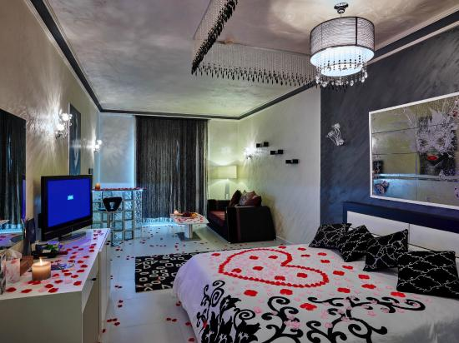
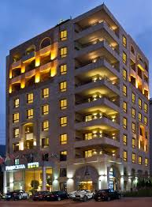
Hotel Princessa is the main hotel of the tournament, where the technical meeting and banquet will take place. It is situated in Jounieh Bay with the beautiful Sea view, just 10 minutes away from Competition Venue.
Cost: 65 $ USA per person per day.
Half-board service (Breakfast+bed+dinner)
Transfer
Transfer will be provided by organizer (Airport - Hotel – Venue – Hotel - Airport). Transfer price: 30$ per person.
All costs, entrance fees and accommodation costs, have to be paid to the organizer
on the technical meeting.
Visa
Visa will be opened upon arrival at the airport.
Please verify with your travel agent or the Lebanese Embassy or Consulate in your country if a visa is required for your travel to Lebanon. The Organizing Committee will be happy to assist each Delegation member with an official invitation letter before 1st of April 2019.
Insurance
All delegations are responsible to have the necessary coverage in case of accidents or illness. Organizers are not responsible for any liability a case of accident.
Photos & Videos
Professional photographer will be available (advanced registration is required)
Gala-Show
Gymnasts are welcome to participate in the Gala-program with performance of maximum 3 minutes.
Banquet
Banquet will be in the evening on 5th of May. All the details we will let you know later.

WE ARE LOOKING FORWARD TO WELCOME YOU IN OUR COMPETITION
IN LEBANON!

Technical Program – Individual Exercises
 | A | B | B light
Baby  2013  & younger | __________ | Free  BD-7 highest count | Free  BD-5 highest count
Mini  2012-2011 | Free + Rope  BD-7 highest count | Free  BD-7 highest count | Free  BD-5 highest count
Children  2010-2009 | 2 App by choice | Free-BD 9 max  + 1 App by choice-BD-7 | Free  BD-9 max
Pre-Juniors  2008-2007 | 2 App by choice | 1 App by choice | ___________
Juniors  2006-2004 | 3 App by choice  FIG | 2 App by choice  FIG | ___________
Seniors  2003 & older | 3 App by choice  FIG | 2 App by choice  FIG | ___________

Technical program – Group Exercises
 | A | B
Mini  2011 & younger | Free  BD- 7 highest count | Free  BD-5 highest count
Children  2010-2009 | Free- BD 9 max  +1 App by choice BD-3 highest count | Free-BD 9max
Pre-Juniors  2008-2007 | Free- BD 9 max  +1 App by choice BD-3 highest count | Free-BD 9max
Juniors  2006-2004 | 2 Exercises  FIG | 1 Exercise by choice  FIG
Seniors  2003 & older | 2 Exercises  FIG | 1 Exercise by choice  FIG

Registration Form
Country
Club
Coach
Judge
Contact Number
E.mail

Participants
Name of Gymnasts | DOB | Category | floor | rope | hoop | ball | clubs | ribbon

Names of Persons | Country/Club | Date of Arrival | Date of Departure
Hotel Accommodation

