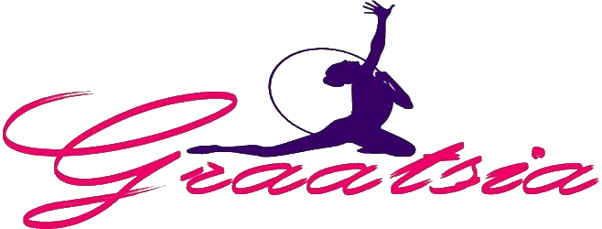

INVITATION

International rhythmic gymnastics tournament “Graatsia Cup” 2019

04.05.2019 – 05.05.2019

Place: Estonia, Keila city, Keila Tervisekeskus competition hall (adress: Paldiski mnt 17)
Organizer: GC Graatsia Maria Hirs 55604587
Diana Dambajeva 55983801
E-mail: vkgraatsia@gmail.com, website: www.vkgraatsia.ee
Participants: The delegation consists of gymnasts, 1 coach and 1 judge.
Start fee per 1 gymnast- 40 EURO. All participants will be awarded by diploms and presents. First three places will receive Trophy Cups.The organizer will also award Misses of the competition by special prizes. Each year of birth will be awarded separately.
Program:
Friday 03.05.2019 – Arrival of the delegations, training in the competition hall
Saturday 04.05.2019 – Judge meeting, 1-st day of the competition, banquet for coaches and judges, GALA show
Sunday 05.05.2019 – 2-nd day of the competition
On Sunday it will be possible to go on a swimming pool in the competition hall. If you are interested, please contact the organizer. The price is 5 EURO per 1 person.
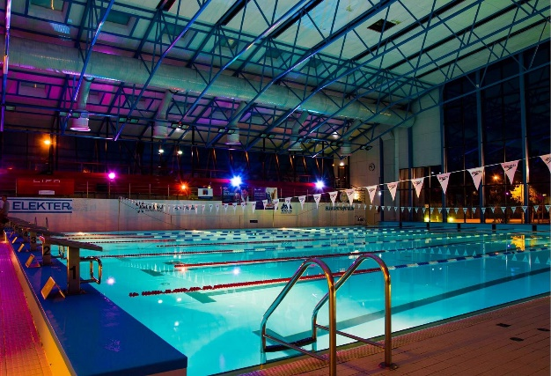

Each club can perform at least 1 performance to the Gala Show on Saturday. PLEASE contact us if your club wants to participate in Gala Show.

Please contact the organizer if you need a hotel, we will offer Hotel Dzingel in Tallinn city, what is 15 minutes far from the competition hall or Keila competition hall Hostel , where is only 29 places.

TECHNICAL PROGRAM

Level A

EXTRA 2013 performance without apparatus

MINI (2012) – FREE HANDS ( 3-7 difficulties)
MINI (2011) – FREE HANDS + 1 APPARATUS BY
CHOICE ( 3-7 difficulties)
CHILDREN (2010, 2009) – FREE HANDS + 2 APPARATUS BY
CHOICE ( 3-7 difficulties)
PRE-JUNIOR (2008, 2007) – 3 APPARATUS BY CHOICE ( 3-7 difficulties)
JUNIOR (2006, 2005, 2004) – 3 APPARATUS BY CHOICE, FIG/UEG RULES
SENIOR – 3 APPARATUS BY CHOICE, FIG RULES

Level B

EXTRA 2013 performance without apparatus

MINI (2012) – FREE HANDS ( 3-7 difficulties)
MINI (2011) – FREE HANDS (D max- 3.0,
3-7 difficulties)
CHILDREN (2010, 2009) – FREE HANDS + 1 APPARATUS BY
CHOICE (D max- 4.0, 3-7 difficulties)
PRE-JUNIOR (2008, 2007) – 2 APPARATUS BY CHOICE (D max-
6.0, 3-7 difficulties)
JUNIOR (2006, 2005, 2004) – 2 APPARATUS BY CHOICE (D max-
6.0, 3-7 difficulties)

SENIOR – 2 APPARATUS BY CHOICE, FIG RULES

Level C

EXTRA 2013 performance without apparatus
MINI (2012,2011) – FREE HANDS (D max- 2.0,
3-7 difficulties)
CHILDREN (2010, 2009) – FREE HANDS (D max- 3.0,
3-7 difficulties)
PRE-JUNIOR (2008, 2007) – 1 APPARATUS BY CHOICE (D max-
4.0, 3-7 difficulties)
JUNIOR (2006, 2005, 2004) – 1 APPARATUS BY CHOICE (D max-
5.0, 3-7 difficulties)

We kindly ask you to let us know about your preliminary arrival till the 18.03.2019. Final application for participation is 01.04.2019

Best regards our dear friends, hope to see you in May!

Maria and Diana

