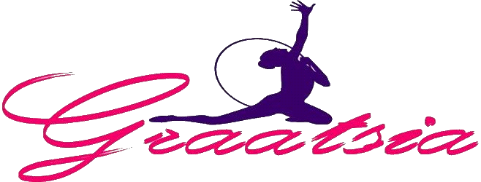

“Graatsia Cup” 2020
16.05.2020– 17.05.2020

Place: Estonia, Keila city, Keila Tervisekeskus competition hall (adress: Paldiski mnt 17)
Organizer: GC Graatsia
E-mail: vkgraatsia@gmail.com, tel: +37255604587,
+37255983801
Participants: The delegation consists of gymnasts, 1 coach and 1 judge.
Start fee per 1 gymnast- 40€. Winners will be awarded by cups and presents. All gymnasts will receive presents. The organizer chooses and awards Miss Graces by special prizes. Each year of birth will be awarded separately.
Registration: https://rgform.eu/event.php?id_prop=1957

Program:
Friday 15.05.2020 - Arrival of the delegations, training in the competition hall
Saturday 16.05.2020 - Judge meeting, competition, GALA
Sunday 17.05.2020 - 2nd day of competition

It is possible to go to a swimming pool in the competition hall. If you are interested, please contact the organizer. The price is 4 EURO per 1 person.
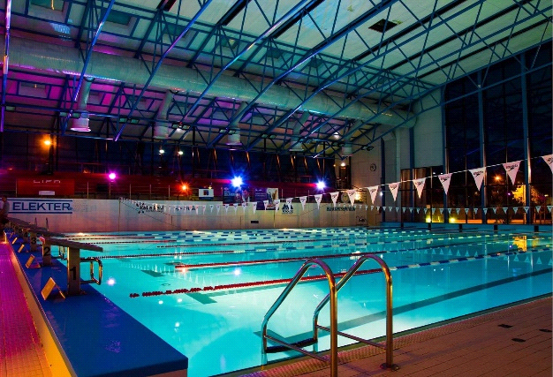

Each club can perform at least 1 performance to the Gala Show on Saturday. Contact us if your club wants to participate in Gala.

Please contact the organizer if you need a hotel, we will offer hotel what is 15 minutes far from the competition hall or Keila Hostel in the competition hall, where is only 29 places.

If you need a transfer, please contact us.

TECHNICAL PROGRAM
Level A
▪︎2014 – out of competition (NO CATEGORY)
▪︎2013 – FREE HANDS ( 3-7 difficulties)
▪︎MINI (2012) – FREE HANDS + 1 APPARATUS BY CHOICE( 3-7 difficulties)
▪︎CHILDREN (2011, 2010) – FREE HANDS + 2 APPARATUS BY CHOICE ( 3-7 difficulties)
▪︎PRE JUNIOR (2009,2008) – 3 APPARATUS BY CHOICE ( 3-7 difficulties)
▪︎JUNIOR (2007,2006,2005) – 3 APPARATUS BY CHOICE, UEG RULES
▪︎SENIOR (2004 and older) – 3 APPARATUS BY CHOICE, FIG RULES

Level B
▪︎2014 – out of competition (NO CATEGORY)
▪︎2013 – FREE HANDS ( 3-7 difficulties) D max 4.0
▪︎MINI (2012) – FREE HANDS ( 3-7 difficulties) D max 4.0
▪︎CHILDREN (2011, 2010) – FREE HANDS + 1 APPARATUS BY CHOICE ( 3-7 difficulties) D max 5.0
▪︎PRE JUNIOR (2009,2008) – 2 APPARATUS BY CHOICE ( 3-7 difficulties) D max 6.0
▪︎JUNIOR (2007,2006,2005) – 2 APPARATUS BY CHOICE, UEG RULES, D max 7.0
▪︎SENIOR (2004 and older) – 2 APPARATUS BY CHOICE, FIG RULES, D max 8.0

Level C
▪︎2014 – out of competition (NO CATEGORY)
▪︎2013 – FREE HANDS ( 3-7 difficulties) D max 2.0
▪︎MINI (2012) – FREE HANDS ( 3-7 difficulties) D max 2.5
▪︎CHILDREN (2011, 2010) – FREE HANDS D max 3.0
▪︎PRE JUNIOR (2009,2008) – 1 APPARATUS BY CHOICE ( 3-7 difficulties) D max 4.0
▪︎JUNIOR (2007,2006,2005) – 1 APPARATUS BY CHOICE, UEG RULES, D max 4.5

BEST REGARDS AND HOPE TO SEE YOU IN KEILA:)

MARIA AND DIANA

